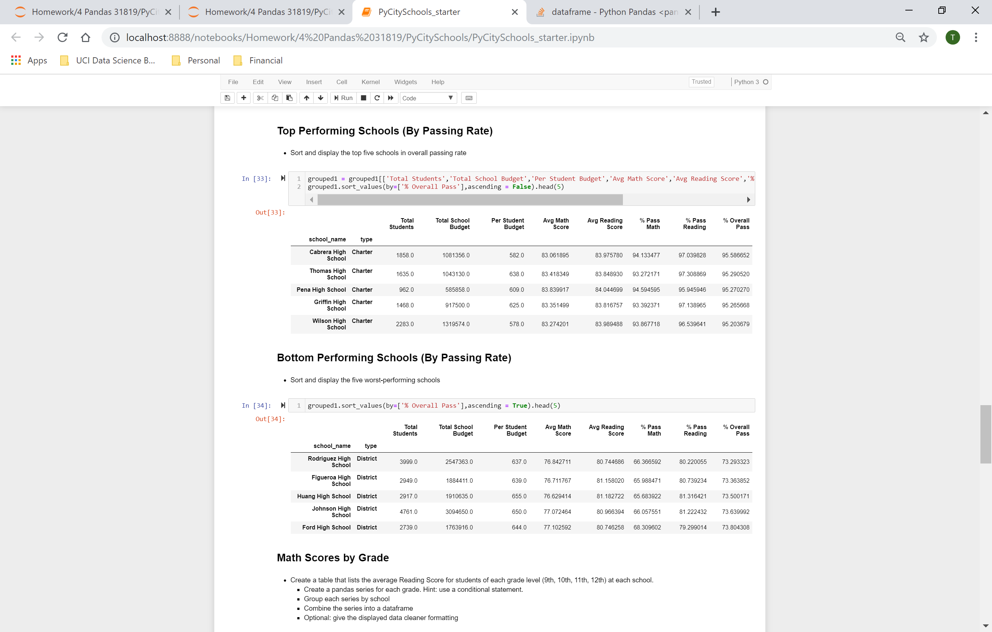

From the above, one can surmise that the larger the class size, the more likely the student will have a lower Overall Passing Percentage.

Also, based on the screenshots above and below, students in charter schools perform markedly better than students in district schools when it comes to math. Smaller class sizes are conducive to higher scores and overall passing percentages.

